## In the partial fulfilment of

**Master of Science – MscIT Sem 7**



**L.J School of Computer Applications, LJKU**

MUSIC STREAMING System

### Developed by: Guided by:

**Name: CHIRAG SINGH**

**Enrollment: 21004500210119**

**Name: SHAH DHRUVIL**

**Enrollment: 21004500210223**

**Name: RAVAL DHRUV**

**Enrollment: 21004500210221**

### L.J. INSTITUTE OF COMPUTER APLLICATIONS

Near Nagdev Kalyan Mandir, Near Sanand Cross Roads,

Sarkhej-Gandhinagar Highway Ahmedabad – 382210

Ph. No. : 9099063417



#### CERTIFICATE

**Enrollment No**: **21004500210119** **Seat No: S2450026105**

This is to certify that **CHIRAG SINGH** of Master of Science (MSc.IT), Semester VI,

Roll No **40** has satisfactorily completed his/her Project titled **MUSIC STREAMING**

in **MERN** under the supervision of internal guide.

**Internal Guide: HOD:**

Ananya Yaduvanshi Dr. Jignesh Doshi

**Date of Submission:**

### L.J. INSTITUTE OF COMPUTER APLLICATIONS

Near Nagdev Kalyan Mandir, Near Sanand Cross Roads,

Sarkhej-Gandhinagar Highway Ahmedabad – 382210

Ph. No. : 9099063417



#### CERTIFICATE

**Enrollment No**: **21004500210183** **Seat No: S2450026197**

This is to certify that **DHRUVIL SHAH** of Master of Science (MSc.IT), Semester VI,

Roll No **35** has satisfactorily completed his/her Project titled **MUSIC STREAMING**

in **MERN** under the supervision of internal guide.

**Internal Guide: HOD:**

. Dr. Jignesh Doshi

**Date of Submission:**

### L.J. INSTITUTE OF COMPUTER APLLICATIONS

Near Nagdev Kalyan Mandir, Near Sanand Cross Roads,

Sarkhej-Gandhinagar Highway Ahmedabad – 382210

Ph. No. : 9099063417



#### CERTIFICATE

**Enrollment No**: **21004500210052** **Seat No:** **S2450026195**

This is to certify that **RAVAL DHRUV** of Master of Science (MSc.IT), Semester VI,

Roll No **33** has satisfactorily completed his/her Project titled **MUSIC STREAMING**

in **MERN** under the supervision of internal guide.

**Internal Guide: HOD:**

. Dr. Jignesh Doshi

**Date of Submission**

|  |  |  |
| --- | --- | --- |
| **Sr.**  **No.** | **TABLE OF CONTENTS** | **Page No.** |
| **1.** | **INTRODUCTION** |  |
|  | 1.1 Existing System |  |
|  | 1.2 Need for the New System |  |
|  | 1.3 Objective of the New System |  |
|  | 1.4 Problem Definition |  |
|  | 1.5 Core Components |  |
|  | 1.6 Project Profile |  |
|  | 1.7 Assumptions and Constraints |  |
|  | 1.8 Advantages and Limitations of the Proposed System |  |
| **2.** | **REQUIREMENT DETERMINATION & ANALYSIS** |  |
|  | 2.1 Requirement Determination |  |
|  | 2.2 Targeted Users |  |
| **3.** | **SYSTEM DESIGN** |  |
|  | 3.1 Use Case Diagram |  |
|  | 3.2 Class Diagram |  |
|  | 3.3 Interaction Diagram |  |
|  | 3.4 Activity Diagram |  |
|  | 3.5 Data Dictionary |  |
| **4.** | **DEVELOPMENT** |  |
|  | 4.1 Coding Standard |  |
|  | 4.2 Screenshots |  |
| **5.** | **AGILE DOCUMENTATION** |  |
|  | 5.1 Agile Project Charter |  |
|  | 5.2 Agile Roadmap / Schedule |  |
|  | 5.3 Agile Project Plan |  |
|  | 5.4 Agile User Story (Minimum 3 Tasks) |  |
|  | 5.5 Agile Release Plan |  |
|  | 5.6 Agile Sprint Backlog |  |
|  | 5.7 Agile Test Plan |  |
|  | 5.8 Earned-value and burn charts |  |
| **6.** | **PROPOSED ENHANCEMENTS** |  |
| **7.** | **CONCLUSION** |  |
| **8.** | **BIBLIOGRAPHY** |  |

**1.** INTRODUCTION

Welcome to Rhythm Realm, your ultimate destination for a seamless music streaming experience. Discover a world of music with personalized recommendations, custom playlists, and an extensive library tailored to your unique taste. Whether you’re looking to dive into curated collections, explore new tracks, or revisit old favorites, Rhythm Realm offers a feature-packed platform that caters to all your musical needs. With secure login, intuitive search tools, and immersive full-screen playback, enjoy music the way it was meant to be heard. Join our community and elevate your listening experience today!

* 1. **Existing System :-**

Project Name: Music Streaming System  
Description: A music streaming platform with features for custom playlists, search functionality, and user recommendations.  
Tech Stack: MongoDB, Express.js, React, Node.js  
Key Features: User authentication, custom playlists, advanced search, responsive design.  
Architecture: React frontend communicates with Node.js backend via Express.js, with data stored in MongoDB.

* 1. **Need For New System :-**

**Rythm Realm**—a next-generation music streaming platform built with the MERN stack, designed to provide a seamless and personalized music experience. Launched with the vision of revolutionizing the way people consume music, Rythm Realm offers a wide array of features that cater to both casual listeners and music enthusiasts.

* Enjoy a fully immersive music experience with the Full-Screen Mode, allowing you to focus entirely on your favourite tracks. Secure Authentication ensures safe access with password verification, Google login, and a "Forgot Password" feature.
* Easily manage music with custom playlists and collections. Clone existing collections or create your own, with advanced search features that make finding music seamless. Personalized recommendations are displayed on the home page based on your activity.
* Use advanced search filters to quickly find specific artists, albums, or tracks. Edit your account details at any time to keep your profile updated. Share your favourite music with friends using the link copy feature.
* Take control of your music with intuitive audio controls. Choose between light and dark themes to match your mood or environment. The platform is fully responsive, ensuring a consistent experience across all devices.
* Exclusive streaming access is available only for registered members, offering a premium experience to all users.

**1.3 Objective of the New System: -**

1. **Enhance User Experience**: Develop a seamless and intuitive interface with full-screen mode, responsive design, and light/dark mode options to cater to diverse user preferences, ensuring an exceptional listening experience across all devices.
2. **Secure and Flexible Authentication**: Implement robust security features, including password login, Google sign-up, and a "Forgot Password" function, to provide users with a safe and flexible authentication process, enhancing trust and ease of use.
3. **Personalized Music Discovery**: Utilize advanced algorithms to offer personalized music recommendations on the home page, based on recent user activity, enabling users to discover new and relevant content effortlessly.
4. **Advanced Search Capabilities**: Integrate a powerful search engine with filters and support for advanced queries like "artist walker," allowing users to find specific artists, albums, or tracks quickly and efficiently.
5. **User-Centric Playlist Management**: Enable users to clone collections, create, edit custom playlists, and organize their music library with search functionality, fostering a personalized and enjoyable music curation experience.
6. **Exclusive Member Features**: Ensure that only registered users can play audio tracks, maintaining a premium and exclusive environment that adds value to the membership experience.
7. **Artist and Content Promotion**: Provide features that support the sharing and promotion of music, such as the link copy feature for tracks, albums, and artists, helping artists and creators reach a broader audience.
8. **Comprehensive Account Management**: Offer a user-friendly account edit option, allowing users to manage and update their profile details with ease, ensuring their account reflects their current preferences.
9. **Innovative Audio Controls**: Implement intuitive audio controls that enhance the user experience by allowing precise management of playback, volume, and other audio settings.
10. **Global Impact and Financial Success**: Align with Rythm Realm's mission to "soundtrack the world" by delivering an innovative and enriching platform that supports the financial success of artists, creators, and industry partners while providing a fulfilling listening experience to users worldwide.
    1. **Problem Defination: -**

Problem Definition:

In today's fast-paced digital world, music lovers face challenges in discovering, organizing, and accessing their favorite tunes seamlessly across devices. Existing music streaming platforms often lack intuitive personalization, robust library management, and user-friendly interfaces, leading to a fragmented listening experience. Additionally, users seek a secure and immersive platform that offers advanced features like personalized recommendations, custom playlists, full-screen playback, and easy sharing of tracks with friends. The absence of a comprehensive solution that integrates these functionalities while ensuring secure authentication and responsive design creates a gap in the music streaming market.

Rhythm Realm aims to address these challenges by providing a secure, feature-rich platform that enhances music discovery, streaming, and sharing, tailored to individual preferences.

* 1. CORE COMPONENTS:-

Core Components of Rhythm Realm:

1. User Authentication & Security:

- Password & Google OAuth2 Login: Ensure secure user access with options for password-based login or Google authentication.

- Forgot Password Functionality: Allow users to reset their password via secure email verification.

- JWT-based Authorization: Provide token-based user sessions to maintain secure, personalized access.

2. Personalized Music Discovery:

- Recommendations Engine: Deliver personalized music suggestions based on user activity and listening history.

- Advanced Search: Enable users to search with filters (artists, albums, tracks) and integrate Spotify API for broader music exploration.

3. Custom Playlists & Library Management:

- Customizable Playlists: Allow users to create, edit, and manage their playlists, as well as clone existing collections.

- Track History: Store and display a user’s listening history for quick access to previously played tracks.

- Playlist Search & Filters: Offer easy organization and retrieval of content within user libraries.

4. Immersive Media Streaming:

- Full-Screen Playback Mode: Provide an enhanced, immersive listening experience with full-screen audio playback.

- Audio Controls: Integrate features like play, pause, skip, and volume control for a smooth listening experience.

- Authenticated Streaming: Restrict streaming to authenticated users, ensuring secure access to premium content.

5. Responsive User Interface:

- Responsive Design: Deliver a consistent user experience across all devices with a fully adaptive interface.

- Light & Dark Modes: Offer customizable themes to enhance user comfort in different lighting environments.

- Sharing Features: Allow users to generate shareable links for tracks, albums, and artists, facilitating easy music sharing.

These core components ensure Rhythm Realm delivers a personalized, secure, and enjoyable music streaming experience.

**Home Page: -**

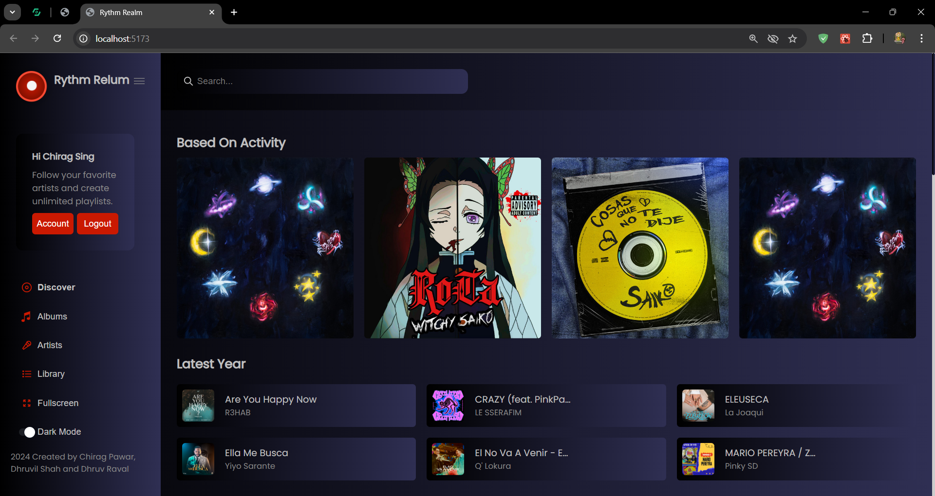

**Signp Page: -**

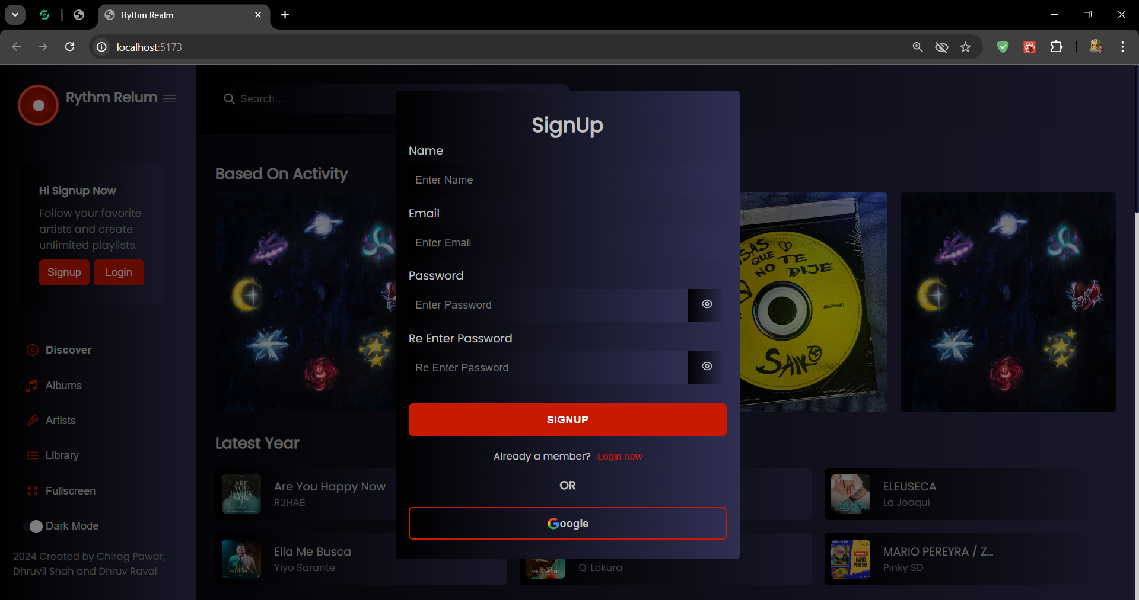

**Login Page: -**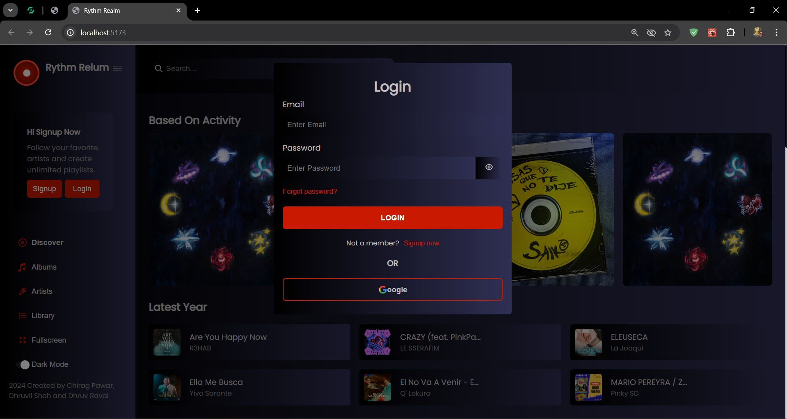

**1.6 Project Profile :-**

|  |  |
| --- | --- |
| **Project Title** | **MUSIC STREAMING** |
| **Front-end** | **HTML5, CSS3, Bootstrap4** |
| **Back End** | **MONGO DB** |
| **Server** | **Apache (Tomcat 9.0)** |
| **Other Tools** | **Power Point, MS Word - 2019** |
| **Diagram Builder** | **Dia.de ,draw.io** |

* 1. **Assumptions and Constraints :-**

Assumptions:-

* **User Authentication**:
* The system assumes users will authenticate either through a password-based login or via Google Login.
* Password-based users will verify their email upon signing up, ensuring legitimate access.
* Google login users will provide a valid Google account with accurate authentication through OAuth.
* **Search Functionality**:
* It is assumed that users will search for music using a variety of filters (e.g., all, artists, albums, tracks).
* The system can handle complex Spotify queries, such as artist: Arjeet Singh walker and assumes the input format is correct.
* **Custom Playlists & Collections**:
* Users can create, edit, and manage playlists as well as collections, which are stored securely in the database.
* The search within the library works accurately across all categories (songs, artists, albums, etc.) for user collections.
* **User Recommendations**:
* The homepage will provide recommendations based on users' past activity (search, playback, etc.).
* The system assumes access to sufficient user activity data for providing accurate recommendations.
* **Responsiveness**:
* The web app will be optimized for various devices (mobile, tablet, desktop) using responsive design principles.
* It is assumed users will access the site from modern web browsers that support the latest HTML5 and CSS3 features.
* **Audio Controls**:
* Users will expect basic audio controls (play, pause, next, previous, volume) for music playback.
* It is assumed that the playback will only be available to logged-in users, preventing unauthorized usage.
* **Data Integrity**:
* All user-related data (e.g., playlists, collections, history) will be stored securely, assuming data integrity through reliable backend services.
* **Third-Party APIs**:
* The Spotify API will be used for music search, and the Google Login API will be utilized for authentication.
* It is assumed that these third-party services will be available and respond appropriately during user interactions.
* **Security**:
* The system assumes secure user authentication and follows best practices for storing sensitive information like passwords (hashed) and API keys.
* Verification emails will be delivered and processed correctly, ensuring secure access to the platform.
* **User Interface Preferences**:
* Users can toggle between light and dark modes as per their preferences, and this choice will be remembered across sessions.

**Constraints:-**

* **Third-Party API Limitations**:
* The platform relies heavily on Spotify's API for search and music-related data. Any limitations or downtime in Spotify’s service could affect functionality.
* Google’s authentication API may be subject to rate limits, affecting user login/signup during heavy traffic.
* **User Authentication**:
* The email verification system is dependent on external email service providers, which may cause delays in account activation if not properly configured.
* Forgotten password requests are time-sensitive, and email links will have a limited validity window to prevent misuse.
* **Audio Playback**:
* Only registered and logged-in users will be allowed to play music. Unauthorized users will be restricted from accessing playback functionalities.
* The quality and availability of audio content will depend on Spotify’s API and its data limits.
* **Responsive Design**:
* While the platform is designed to be responsive, certain high-performance features like full-screen mode might be less effective on smaller devices (e.g., mobile phones).
* **Data Storage**:
* Playlists, user collections, and activity history are stored in the database, which requires sufficient storage and fast retrieval times to ensure a smooth user experience.
* Any delay or failure in the database may affect the availability of user-specific features, such as custom playlists or recommendations.
* **User Experience**:
* Full-screen mode may not be available or fully functional on all web browsers or devices, especially older or less commonly used ones.
* Switching between light and dark modes may experience slight delays on certain devices due to rendering constraints.
* **Search Query Complexity**:
* Complex search queries relying on Spotify's API might not return accurate or expected results, especially when querying lesser-known artists, tracks, or albums.
* The search filter may not handle very large volumes of data or highly intricate queries smoothly without optimization.
* **Google Login**:
* Users opting for Google login/signup are dependent on the Google OAuth flow, which could cause access issues if Google services experience any disruptions.
* **Rate Limiting**:
* The use of Spotify and Google APIs is subject to rate limits, potentially restricting certain features during periods of heavy user activity.
* **User Data Privacy**:
* The platform assumes users consent to store activity and interaction data (e.g., playlists, listening history) to offer personalized recommendations, abiding by data privacy regulations such as GDPR.

**1.8 Advantages and Limitations of the Proposed System:-**

### Advantages

* **Personalized Experience**: Custom playlists, collections, and activity-based recommendations offer a unique and tailored music journey.
* **Convenient Authentication**: Users can sign up securely using either password-based or Google login for flexible access.
* **Advanced Search**: Filtered search options and Rhythm Realm queries allow for precise music discovery.
* **Responsive Design**: Seamless experience across mobile, tablet, and desktop ensures optimal usability on any device.
* **User Controls**: Light/dark modes and intuitive audio controls enhance user comfort and interaction.

**Limitations**

* **API Dependence**: Heavy reliance on Spotify and Google APIs may lead to disruptions or rate-limiting during high traffic.
* **Authentication Delays**: Email verification and password recovery are dependent on external services, which may cause delays.
* **Device Compatibility**: Full-screen mode and certain features might not perform well on older or less commonly used devices.

**2 REQUIREMENT DETERMINATION**

**& ANALYSIS**

**2.1 Requirement Determination :-**

Necessity resolve for the music streaming platform involves gathering user and system needs to build a feature-rich and functional solution. The platform will offer secure authentication through password login and Google OAuth, ensuring flexibility for users. Additionally, email verification for password-based sign-up and password recovery are essential to enhance user security. The system must also support personalized features like user-created playlists, collections, and activity-based recommendations, providing an intuitive and engaging music discovery experience.

The platform’s search functionality requires a robust integration with the Spotify API to handle filtered searches by artists, albums, and tracks. It must also support complex queries, allowing users to search by specific terms like `artist: Arjeet Singh`. The application will provide responsive design to accommodate multiple devices, ensuring seamless performance across mobile, tablet, and desktop environments. Features like light/dark mode, link-sharing for tracks or albums, and audio playback controls are key components of the user interface.

From a technical perspective, the platform depends on the reliable integration of third-party APIs (Spotify and Google) and secure storage of user data, including playlists and history. Proper backend development using Node.js and MongoDB ensures scalability and performance, while maintaining security protocols such as hashed passwords and HTTPS communication.

**2.2 Targeted Users :-**

* Music Enthusiasts: Individuals passionate about discovering and streaming music across various genres and artists.
* College Students: Young users who enjoy personalized recommendations, playlist creation, and mobile-friendly design.
* Professionals: Employees or freelancers looking for an efficient way to stream music while working or during breaks.
* Music Content Creators: Users who are deeply involved in curating their music collections and building playlists for personal or shared use.
* Tech-Savvy Users: Individuals familiar with platforms like Spotify and Google services, seeking advanced search options and seamless integration with APIs.

**3. SYSTEM DESIGN**

**3.1 Use Case Diagram :-**

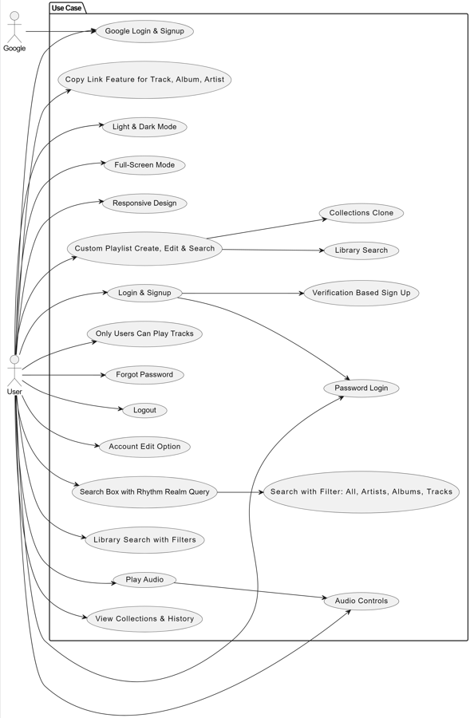

**3.3 Interaction Diagram :-**

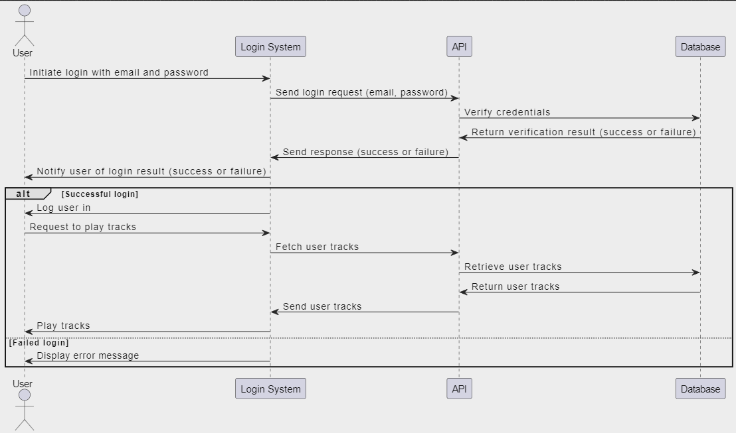

**3.4** **Activity Diagram :-**

* Add Playlist

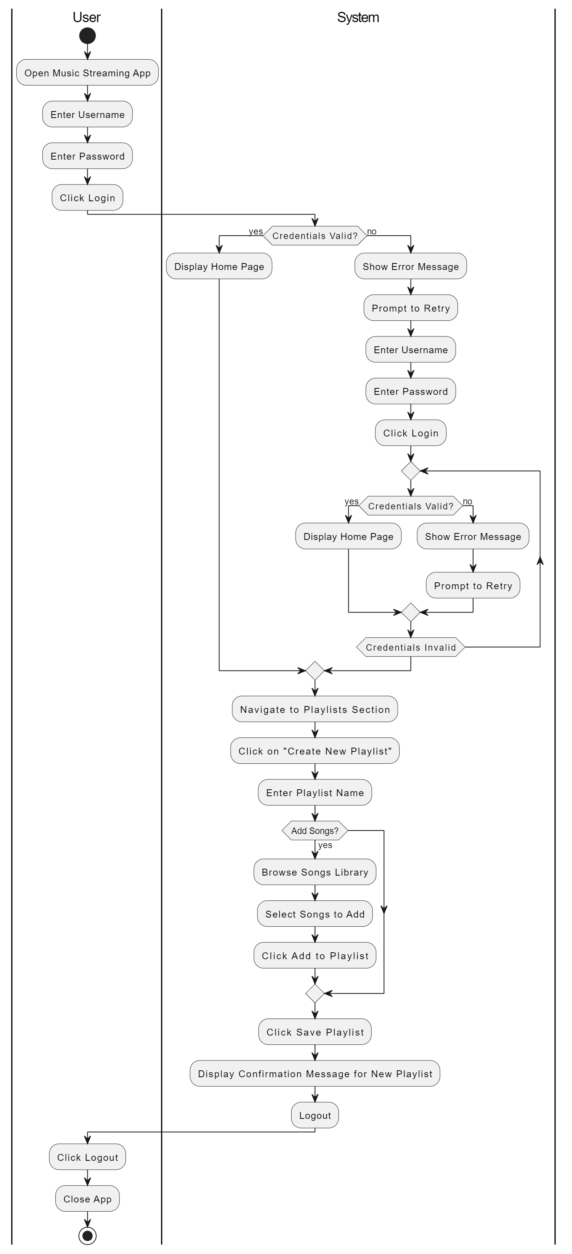

* Edit Profile
* Edit Profile

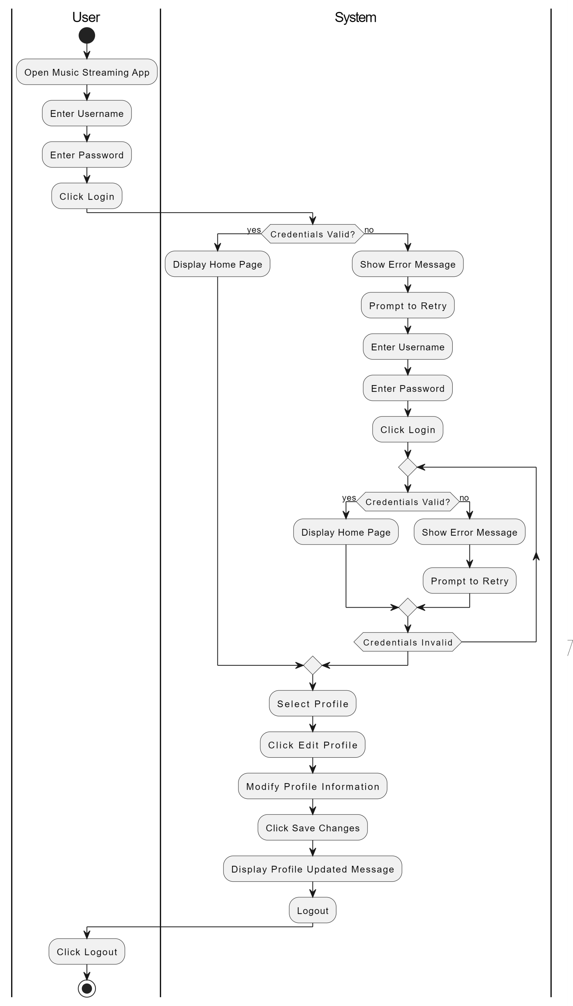

**3.6 Class Diagram :-**

**3.5** **Class Diagram :-**

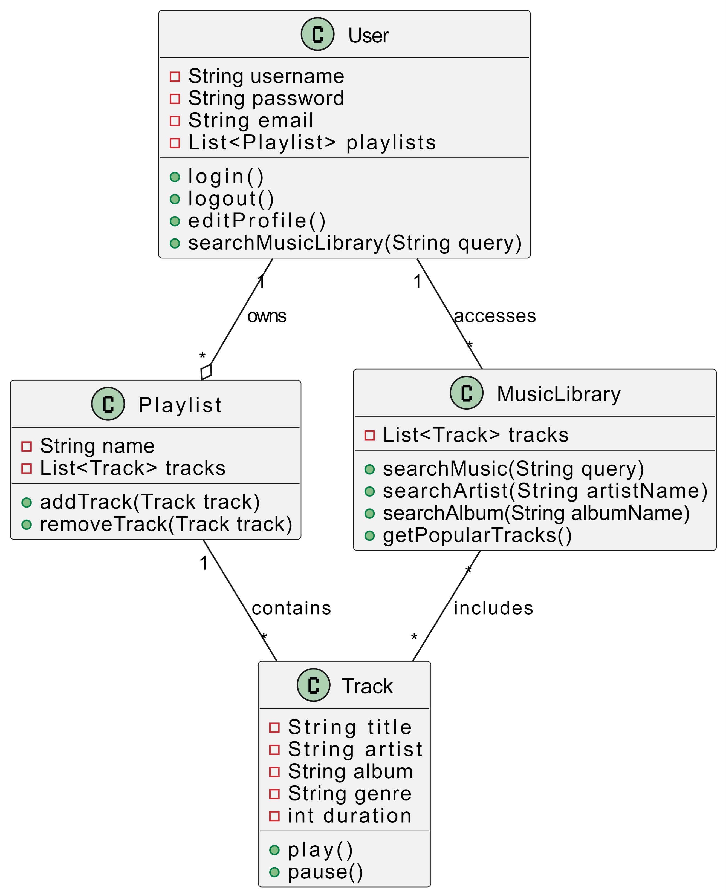

**3.6 Data Dictionary :-**

* **Students Pending Projects:**

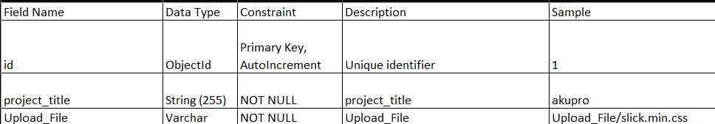

* **Students Requirement model:**

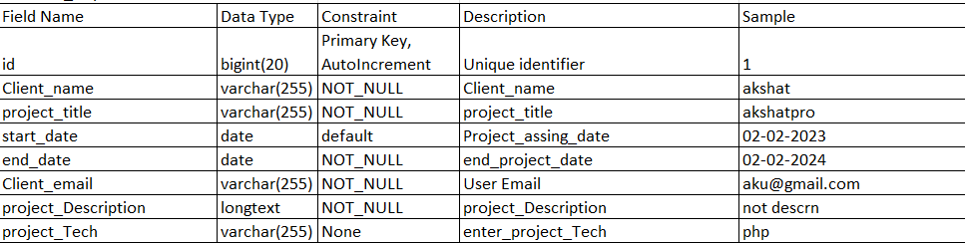

* Student user model:

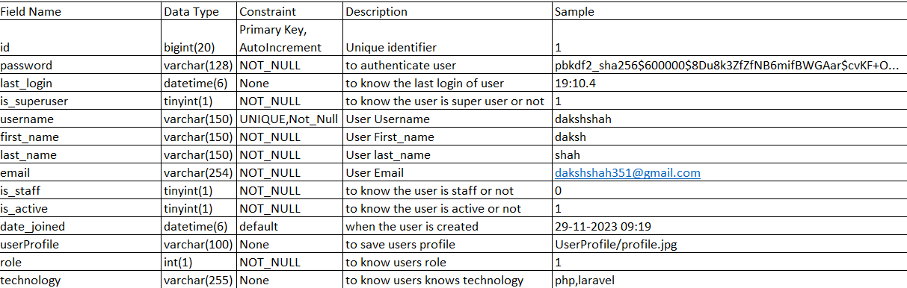

**4. Development**

**4.1 Coding Standard :-**

Naming conventions make sure programmer know how to name variable and classes so that they will be consistent and contain all the right information.

Classes, Enums, typedefs, and extensions name should in Upper CamelCase.Packages, Libraries, Directories, and source files name should be insnake_case(lowercase _ with _underscores).

Documentation comments with three quotes (""") are used for documenting thecode. Anything you think will stay in the code forever should use this style ofcomments.

**4.2**  **Screenshots :-**

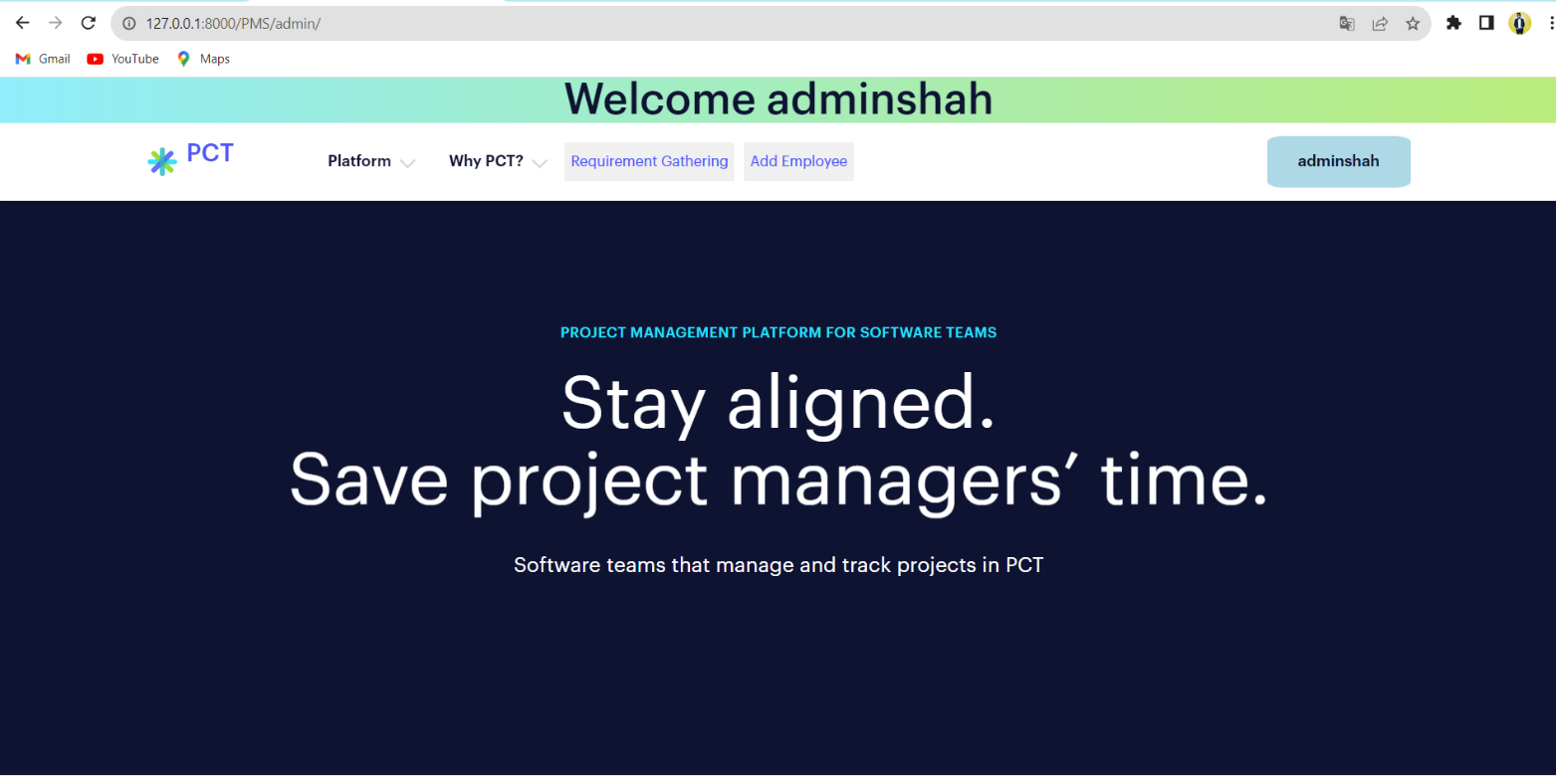

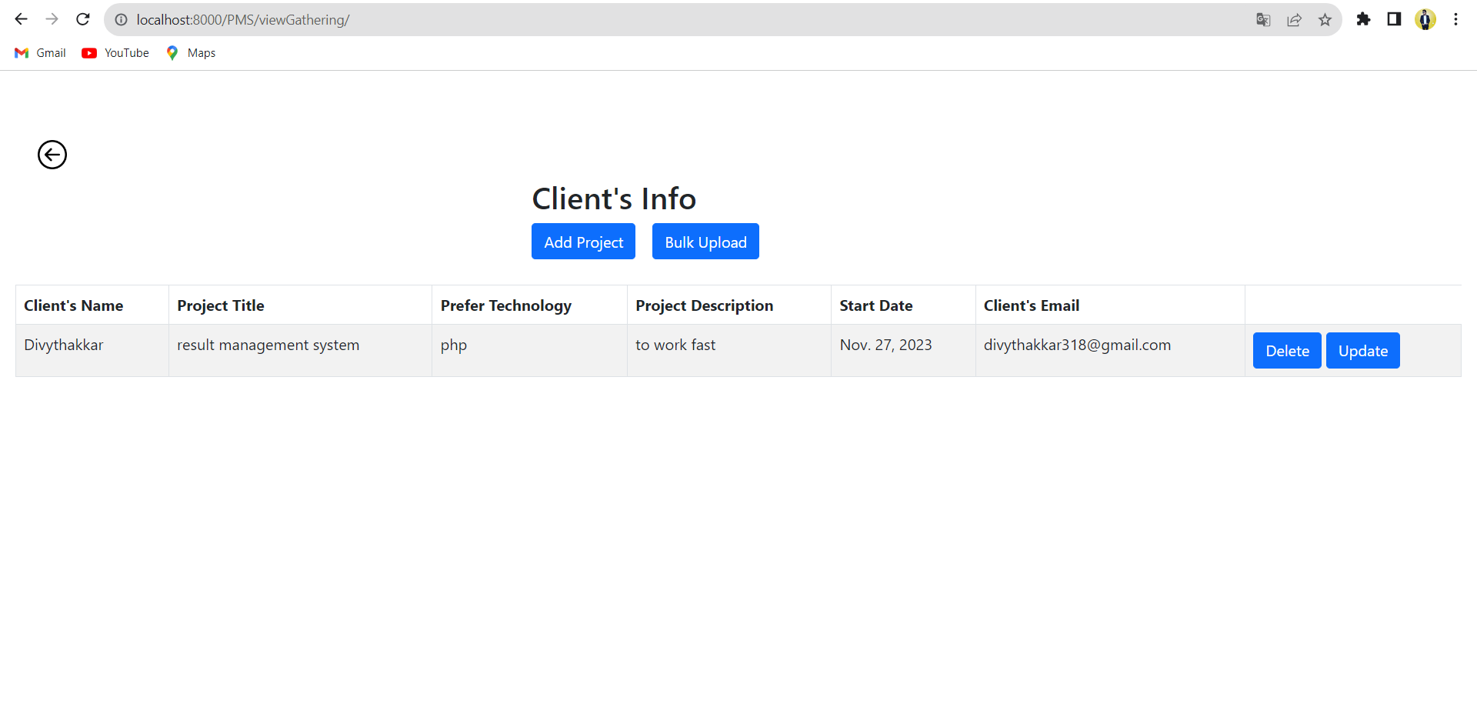

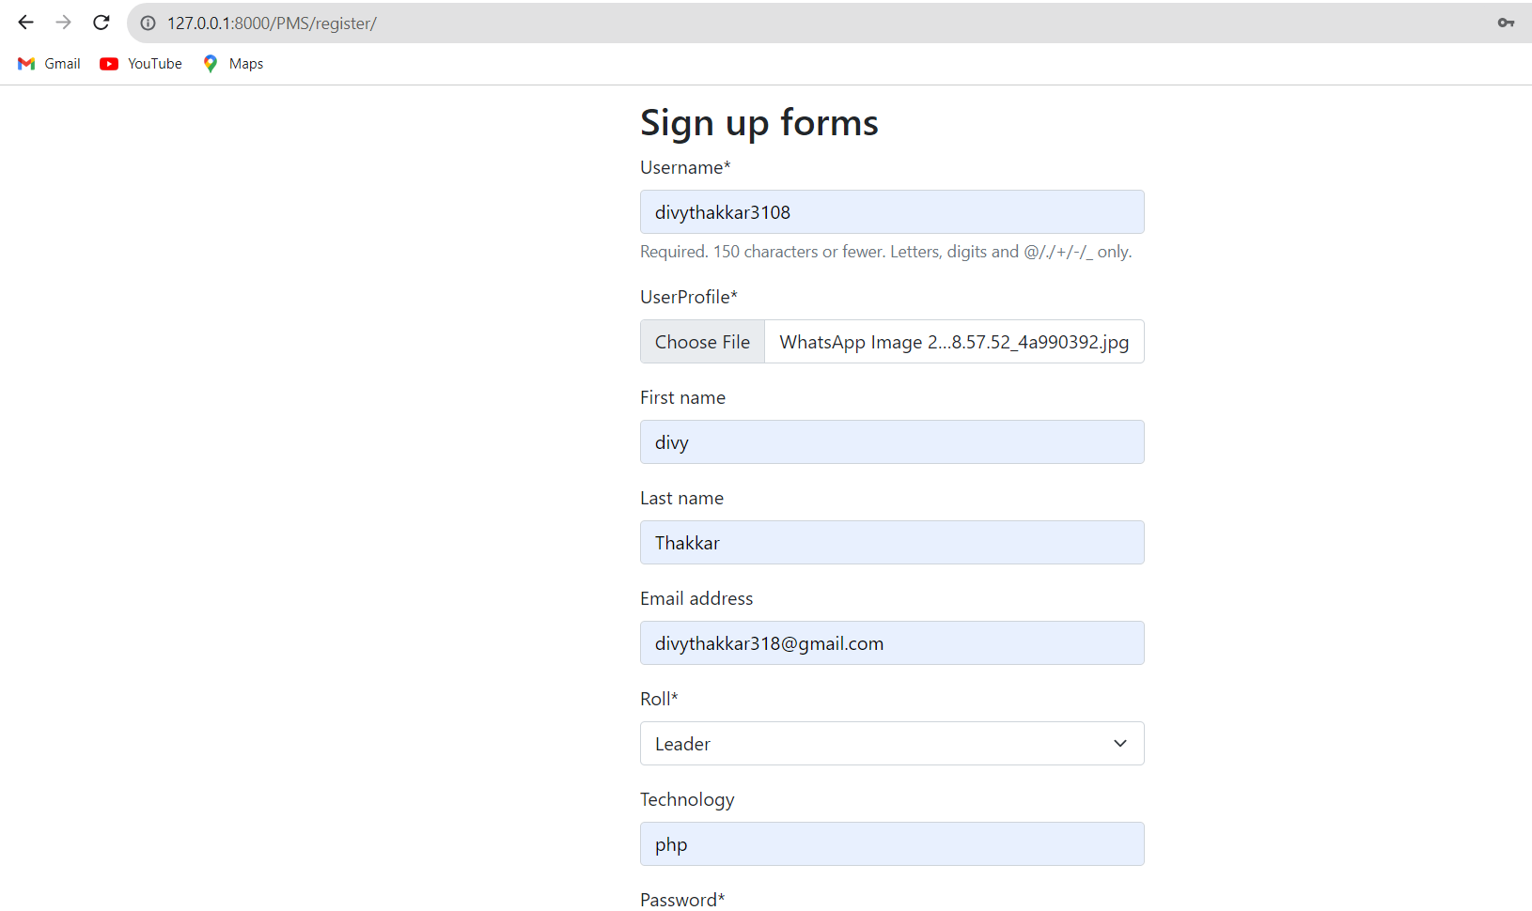

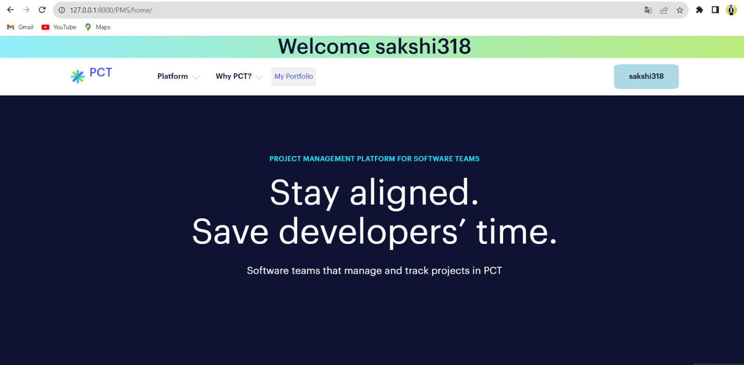

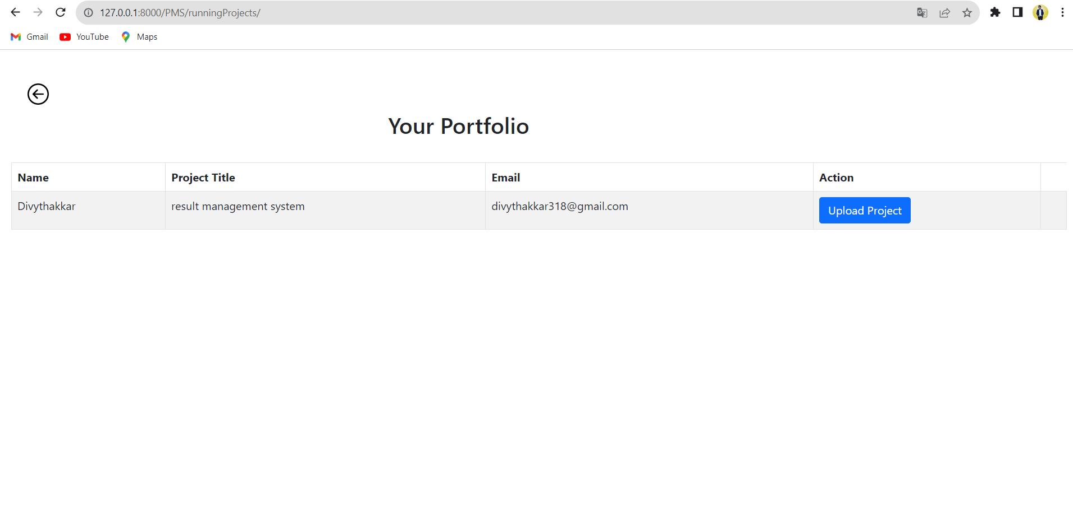

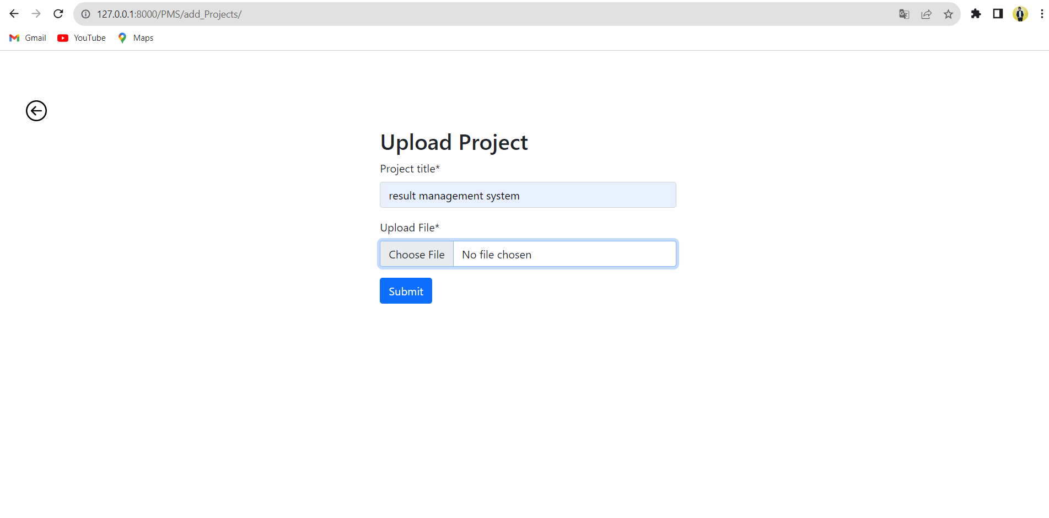

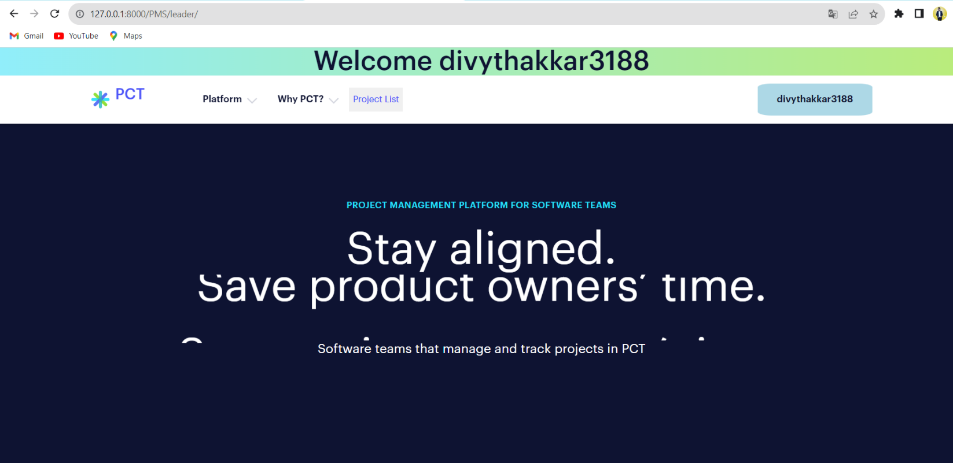

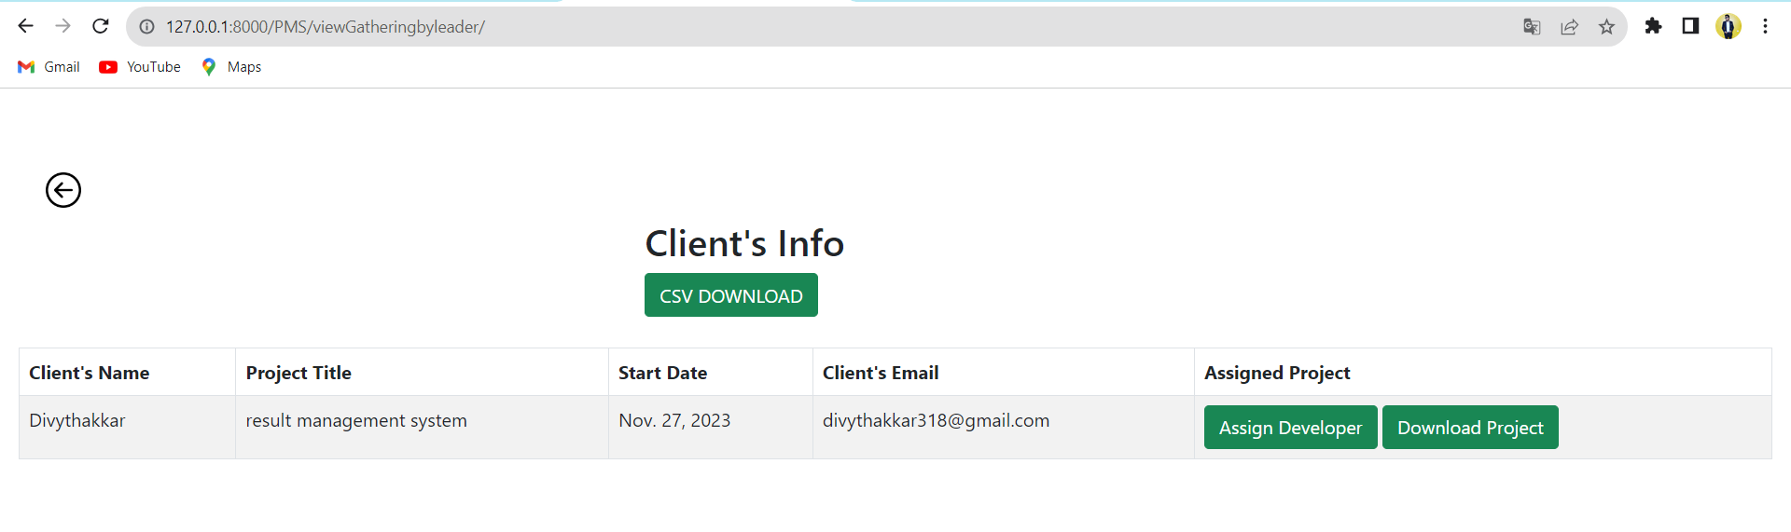

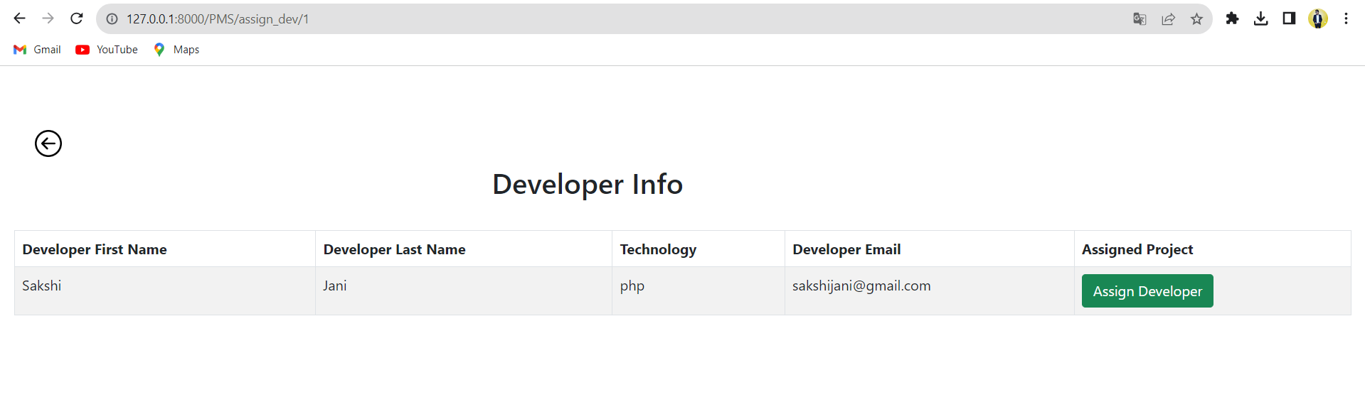

**5. Agile Documentation**

**5.1 Agile Project Charter :**

* **Project Charter:**

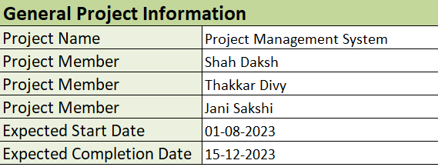

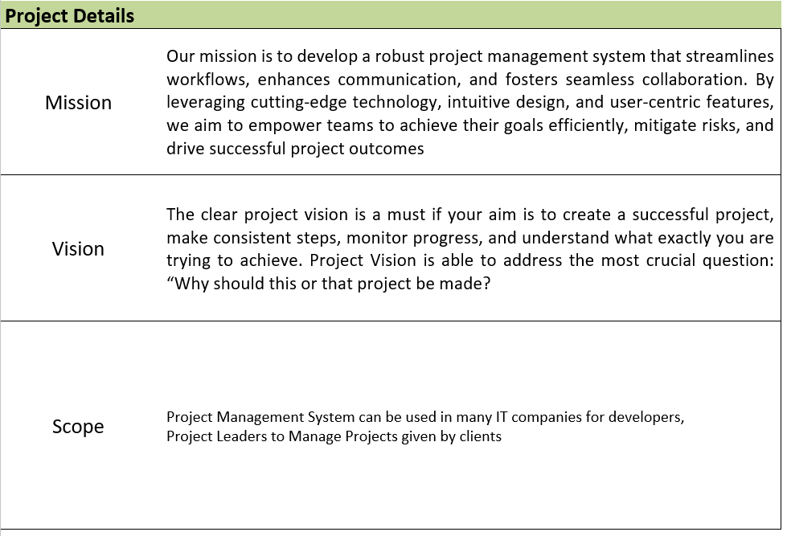

**5.2 Agile Roadmap / Schedule :**

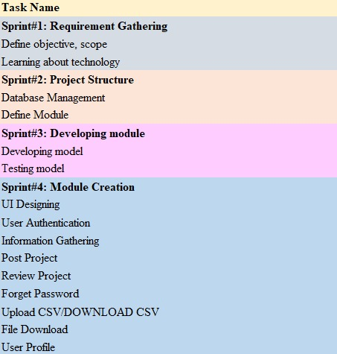

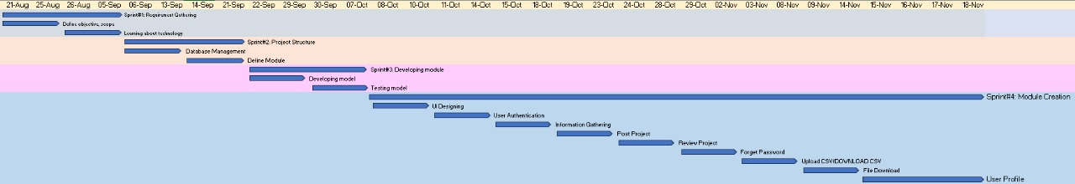

**5.3 Agile Project Plan :**

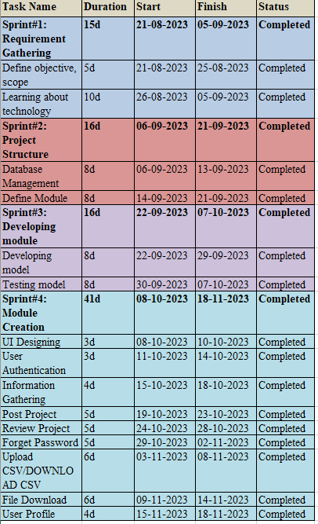

**5.4 Agile User Story :**

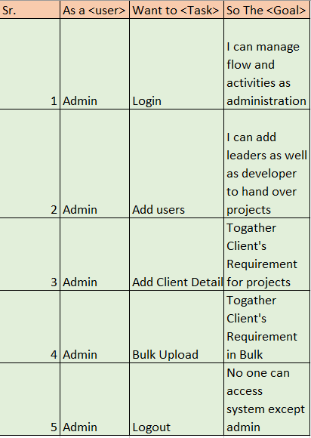

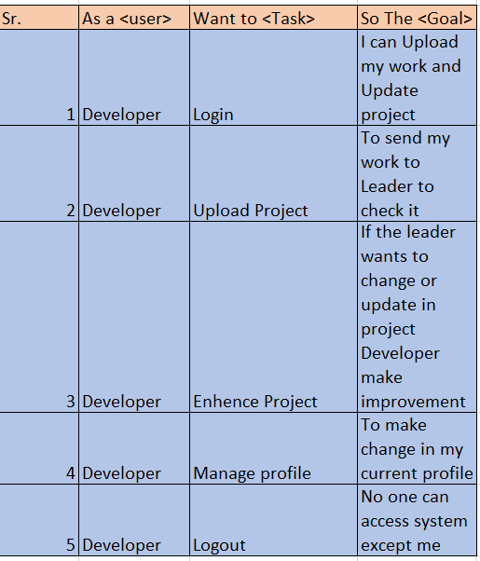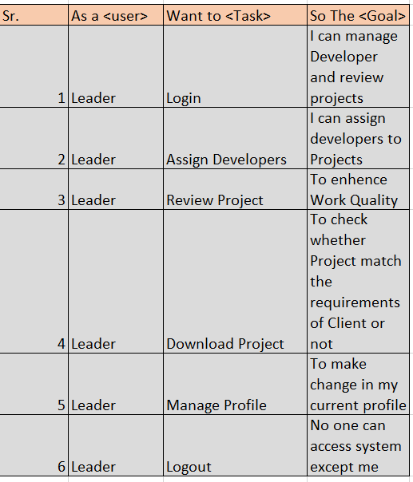

**5.5 Agile Release Plan :**



**5.6 Agile Sprint Backlog :**

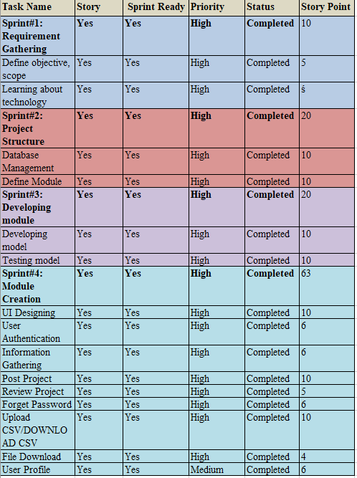

**5.7 Agile Test Plan :**

* **LOGIN :**

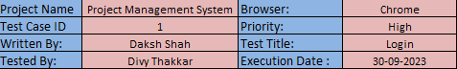

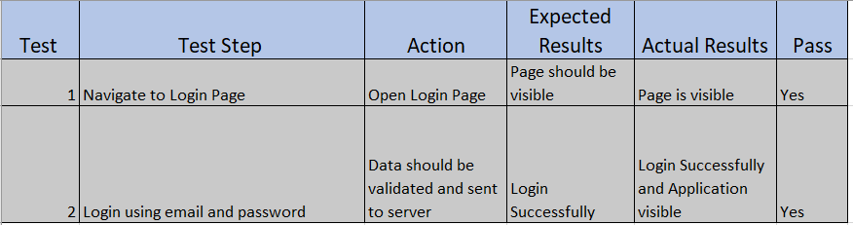

* **UPLOAD PROJECT :**

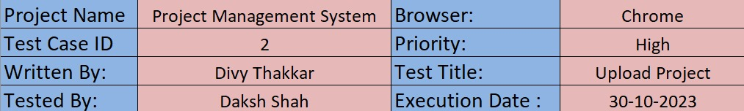

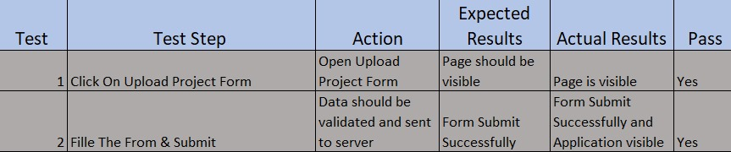

**5.8 Earned-value and burn charts :**

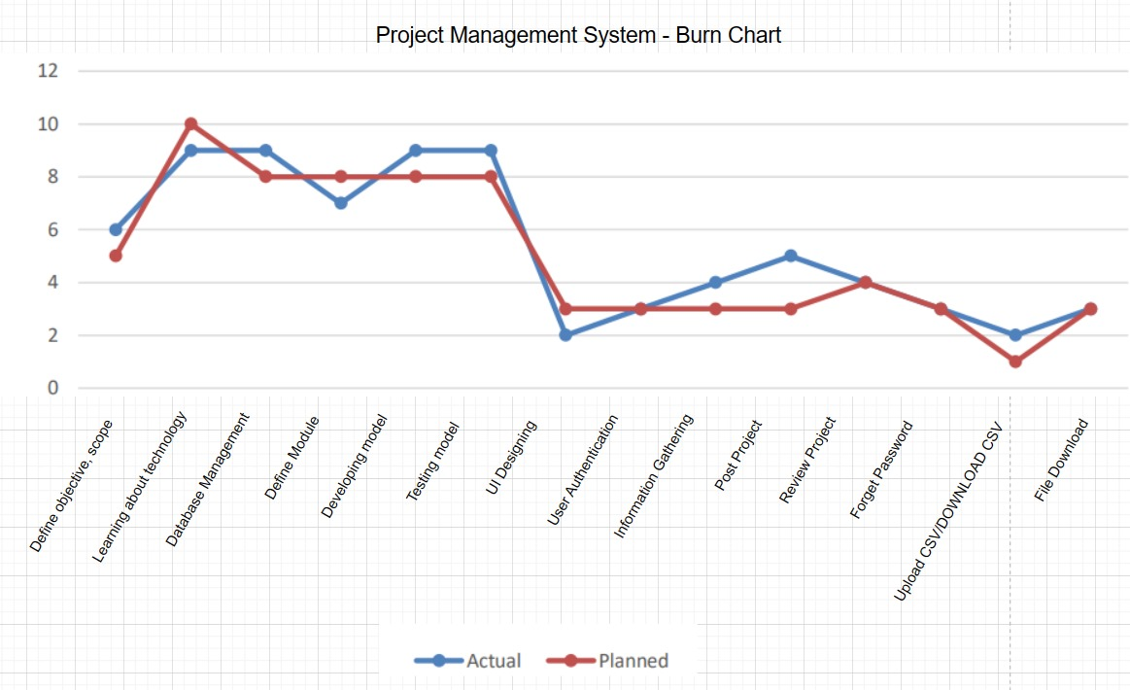

**6. PROPOSED ENHANCEMENTS**

* Upload Project by Developer
* Review Project by Leader
* Manage User Profile
* Download CSV

**7. CONCLUSION**

Rythm Realm is an incredibly effective platform that offers significant advantages over traditional music consumption methods. These benefits include centralized access to a vast music library, real-time updates on new releases and trends, user-friendly design, and reliable data management with regular backups. The intuitive interface makes it easy for users to navigate, enhancing their experience and making it simple to adopt and enjoy the platform.

**8. BIBLIOGRAPHY**

* <https://Hiva.com>
* <https://Trello.com>
* <https://Asana.com>